**COMMANDS:**

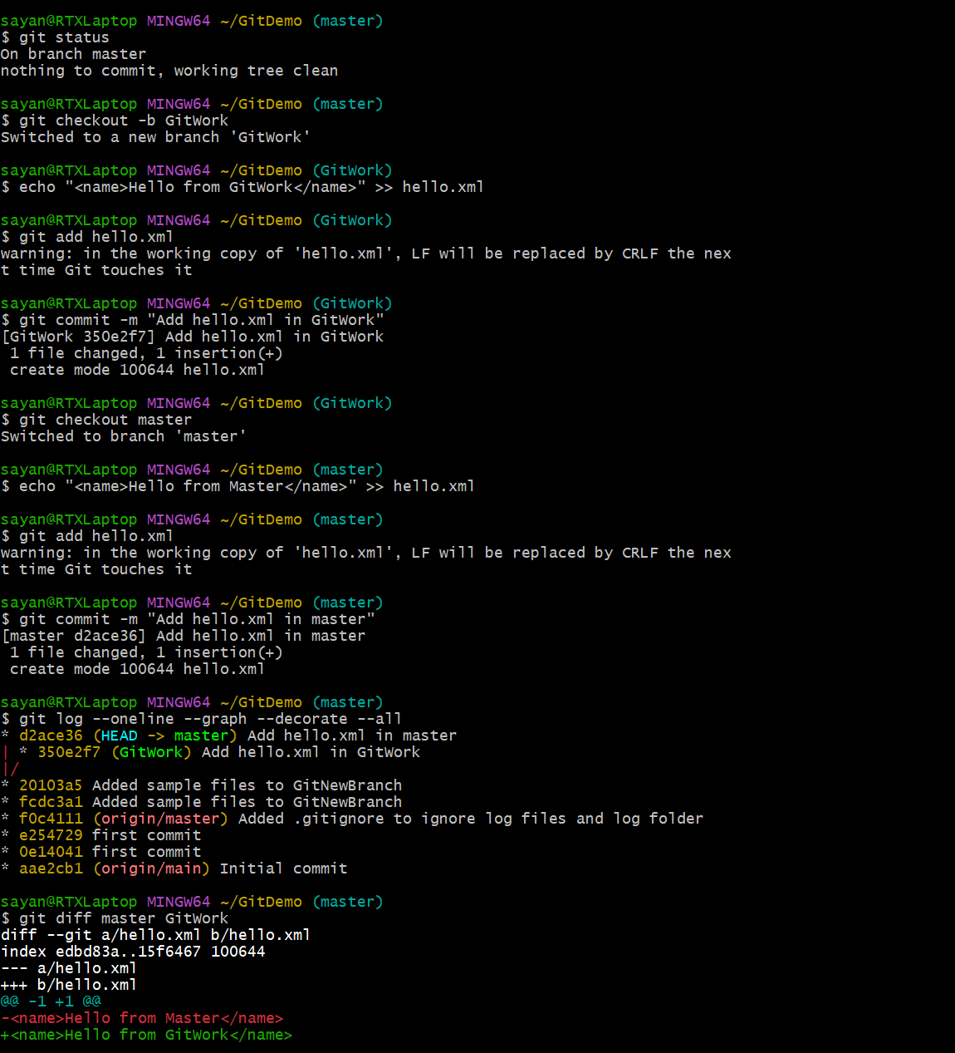

//Check branch status

//Create new branch

//Create hello.xml

//commit

//switch to new branch

//Create hello.xml

//add hello.xml

//commit

//log

//difference

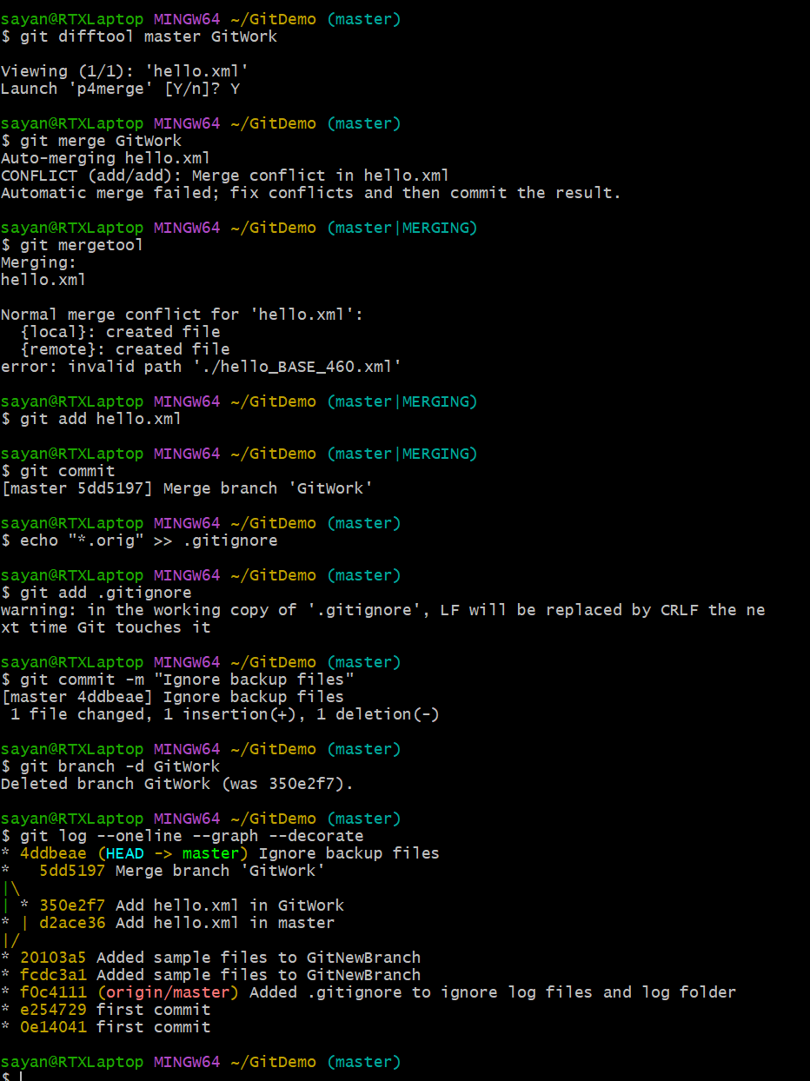

//difference using p4merge

//merge to get conflict

//solve conflict

//add

//commit

//ignore backup files

//commit

//delete branch

//log

**In p4Merge, to view difference**

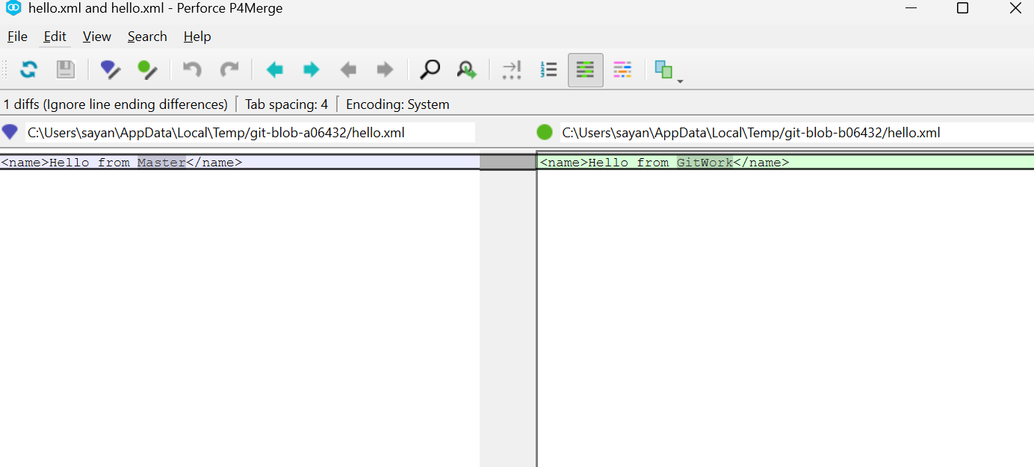

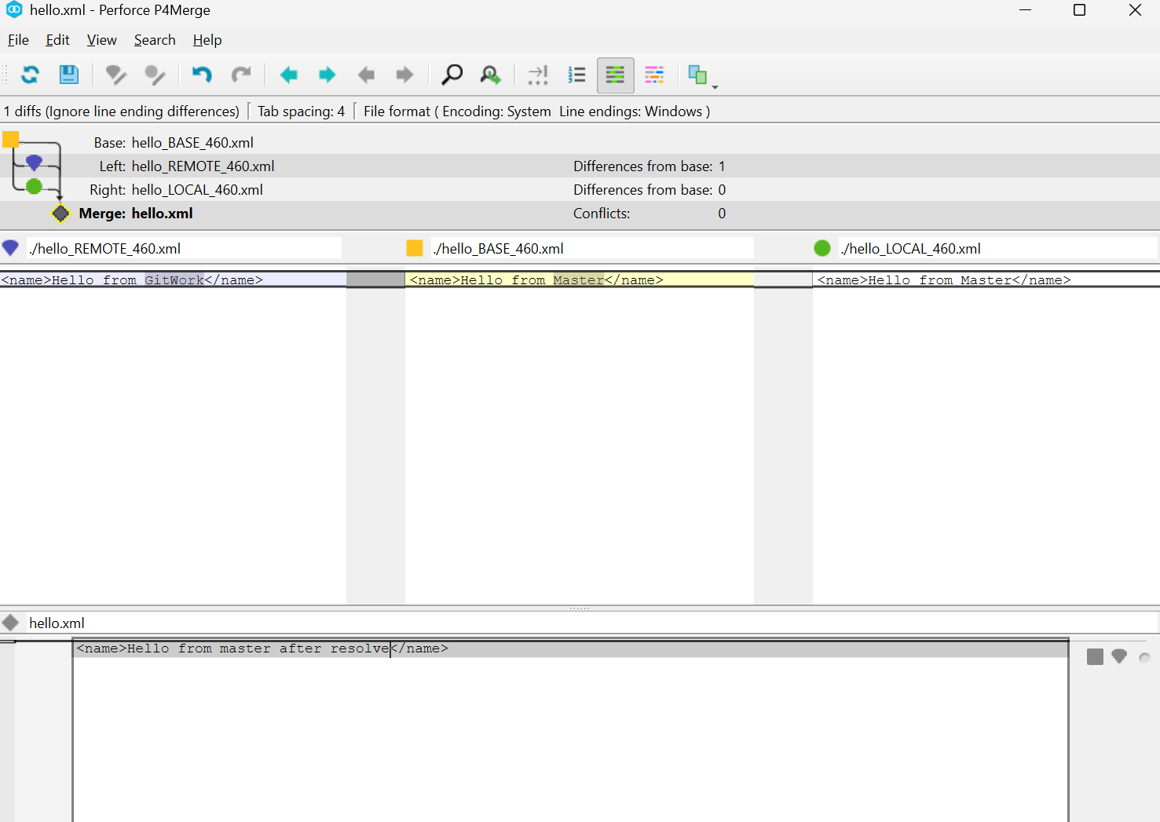

**In p4Merge, while resolving conflict**